Micro-environmental variation of soil microbial biodiversity differs across land use types – implications for field sampling designs

Álvarez, Valeria E.^{a,b,*}, El Mujtar, Verónica A.ª, Falcão Salles, Joana^{c}, Jia, Xiu^{c}, Castán, Elisaª, Cardozo, Andrea^{a,d}, Tittonell, Pablo A.^{a,c,e}

ªAgroecology, Environment and Systems Group, Instituto de Investigaciones Forestales y Agropecuarias de Bariloche (IFAB) - Instituto Nacional de Tecnología Agropecuaria-Consejo Nacional de Investigaciones Científicas y Técnicas (INTA-CONICET), Modesta Victoria 4450 - CC 277 (8400), San Carlos de Bariloche, Río Negro, Argentina.
^{b}Instituto Tecnológico de Chascomús (INTECH), CONICET-UNSAM, Avenida Intendente Marino Km 8.2 (7130), Chascomús, Buenos Aires, Argentina.
^{c}Groningen Institute of Evolutionary Life Sciences (GELIFES), Groningen University, PO Box 11103, 17 9700 CC Groningen, The Netherlands.
^{d}Agencia de Extensión Rural de El Bolsón, Instituto Nacional de Tecnología Agropecuaria (INTA), El Bolsón, Río Negro, Argentina.
^{e}Agroécologie et Intensification Durable (AïDA), Centre de Coopération Internationale en Recherche Agronomique pour le Développement (CIRAD), Université de Montpellier, 34000 Montpellier, France.

* Corresponding author e-mail adress: alvarez.valeria@inta.gob.ar

Supplementary Figures

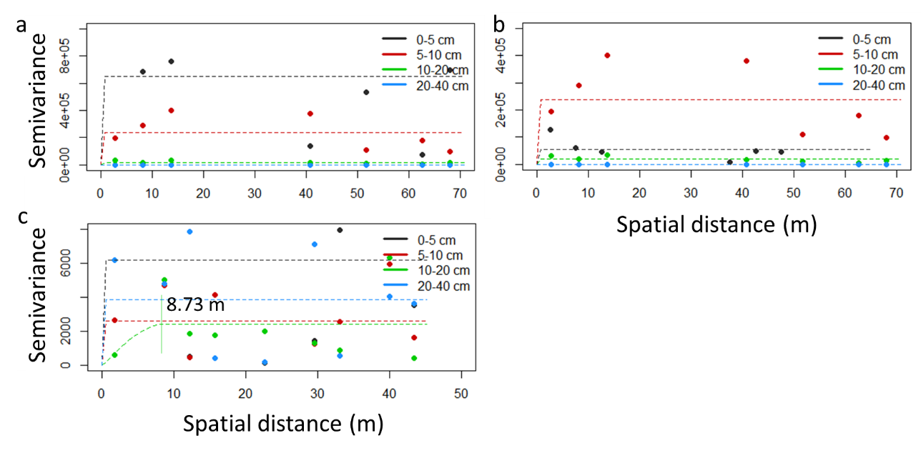
Figure S1. Empirical semivariograms (dots) and spherical fitted model (dash lines) for microbial biomass in forest (a), grassland (b) and horticulture (c) land.

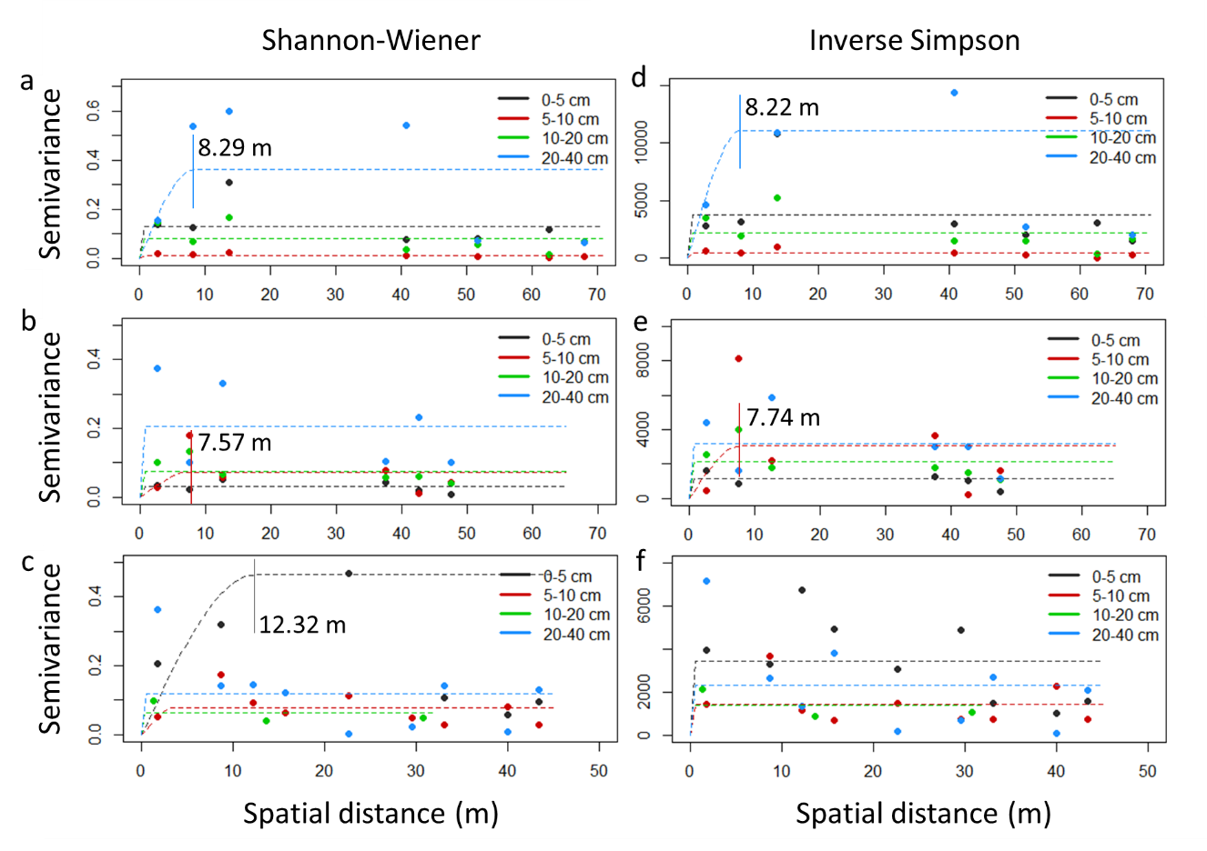
Figure S2. Empirical semivariograms (dots) and spherical fitted model (dash lines) for Shannon-Wiener (a-c) and Inverse Simpson indexes (d-f) indexes in forest (a, d), grassland (b, e) and horticulture (c, f) land. Vertical lines signalize the limit of spatial dependence and the corresponding practical range value in cases where autocorrelation exist.
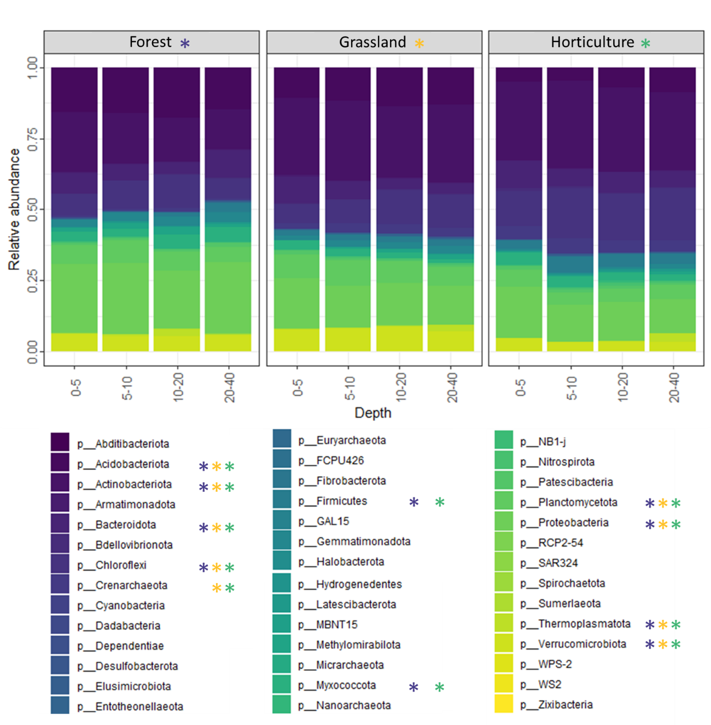
Figure S3. Relative abundance of microbial taxa at phylum level for each depth class by land use. Stars denotes the most important phyla contributing to community turnover among depth classes in forest, grassland and horticulture lands resulting from SIMPER analysis.

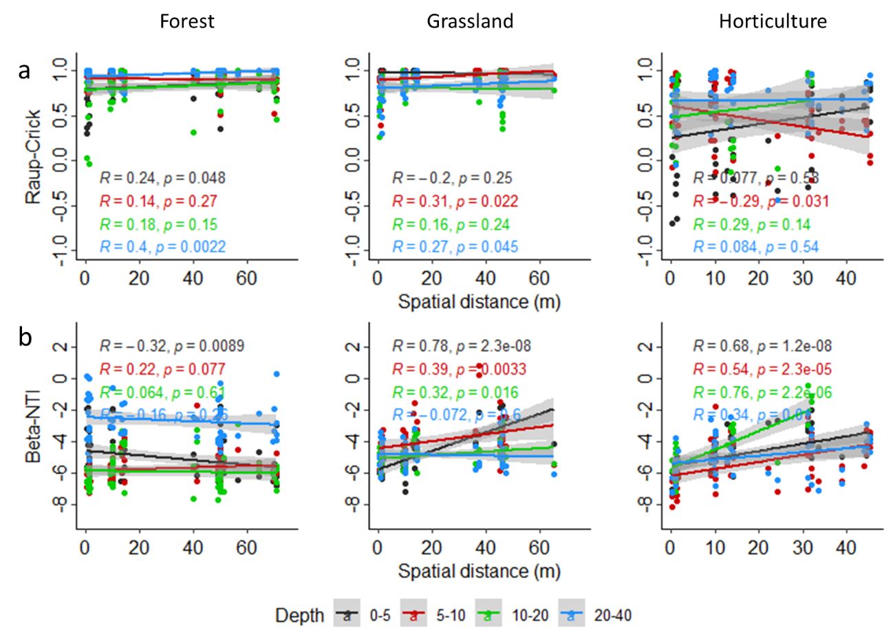
Figures S4. Correlation of Raup-Crick (Bray-Curtis) dissimilarity (a) and β-nearest taxon index (β-NTI) (b) and Euclidean distance matrix of spatial distance for each soil depth at forest, grassland and horticulture land use.

