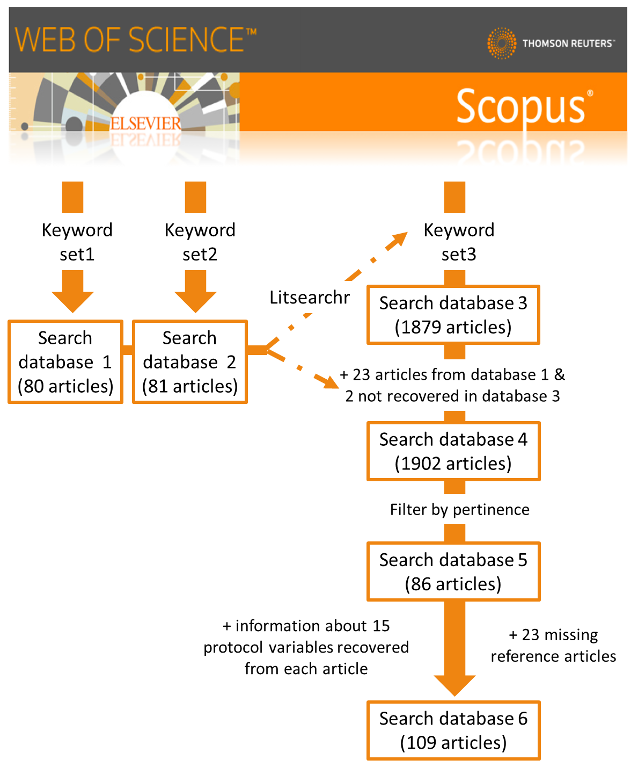
Figure S1. Workflow implemented for systematic literature search performed on Scopus (Search 2).

.

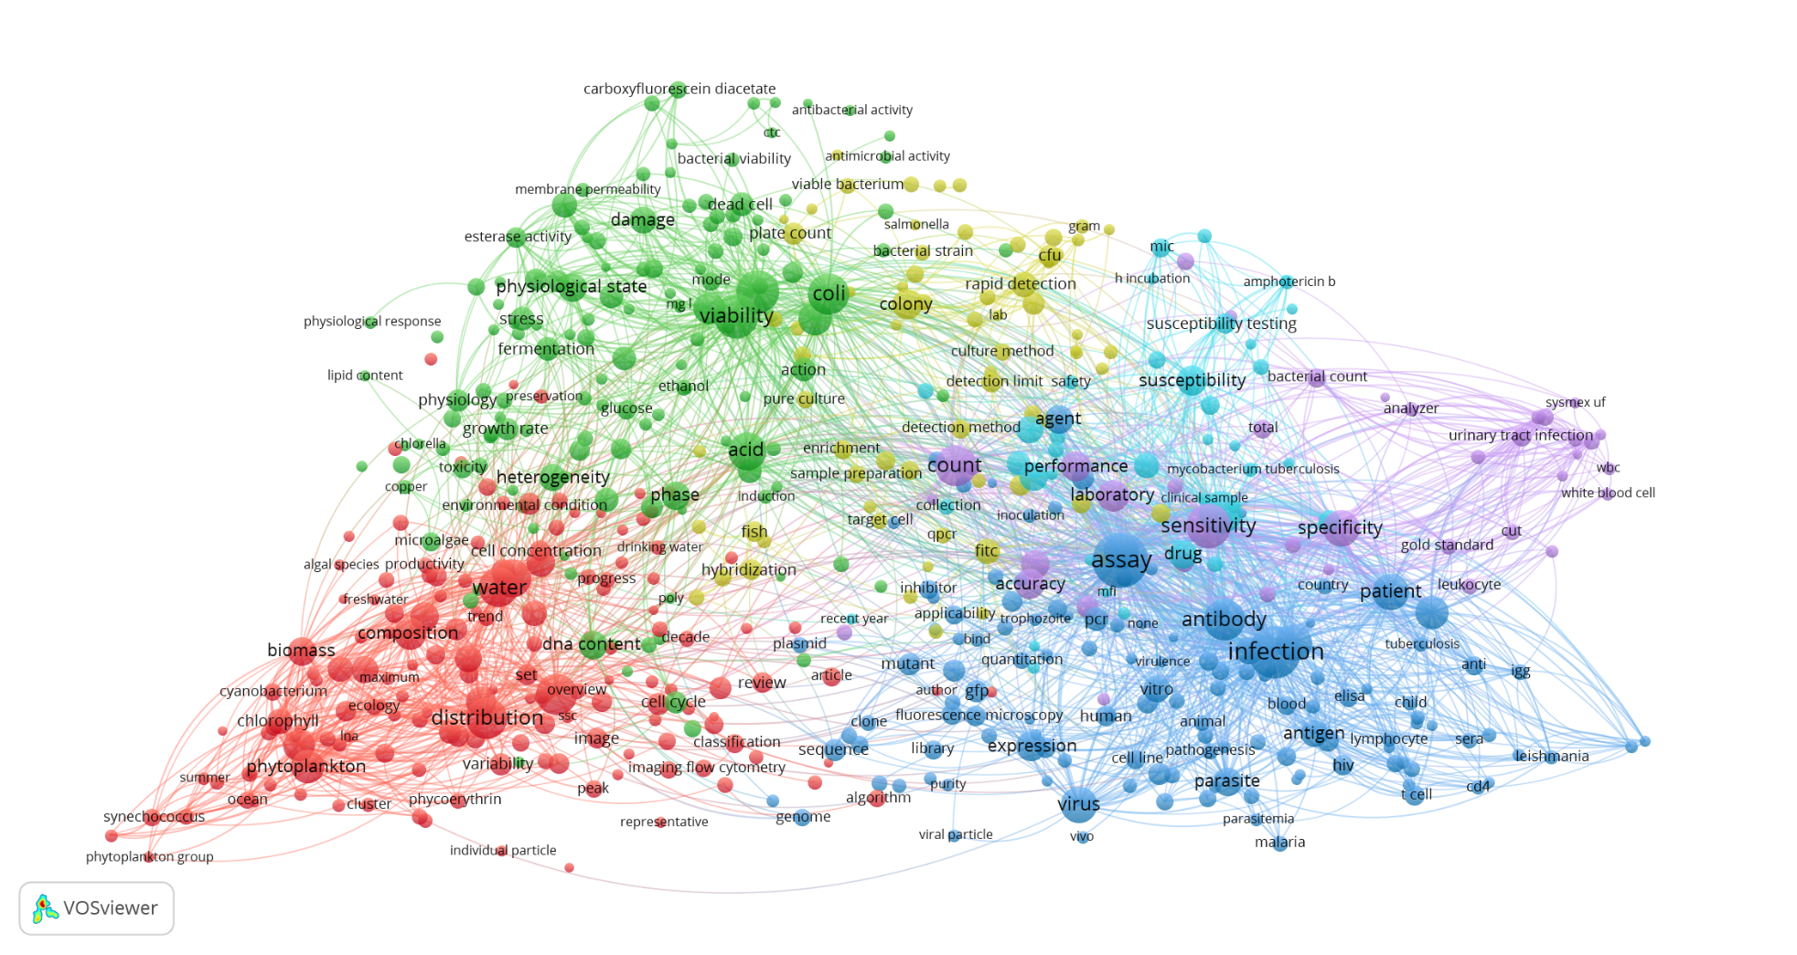

Figure S2. Network of co-occurrence of terms (title and abstract) from a subset of 1,880 articles focused on microbial analyses by flow cytometry. The network was based on a minimum of 10 co-occurrences between two terms. Clusters of terms are identified by colours. Size of bubbles and text is proportional to term´s frequency, and thickness of connections to the number of co-occurrence.
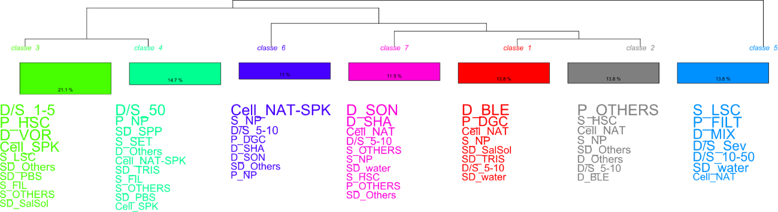

Figure S3. Dendrogram of the Reinert’s classes with word cloud graph. Size of each modality is proportional to its Chi square value and indicates the association strength with the class.

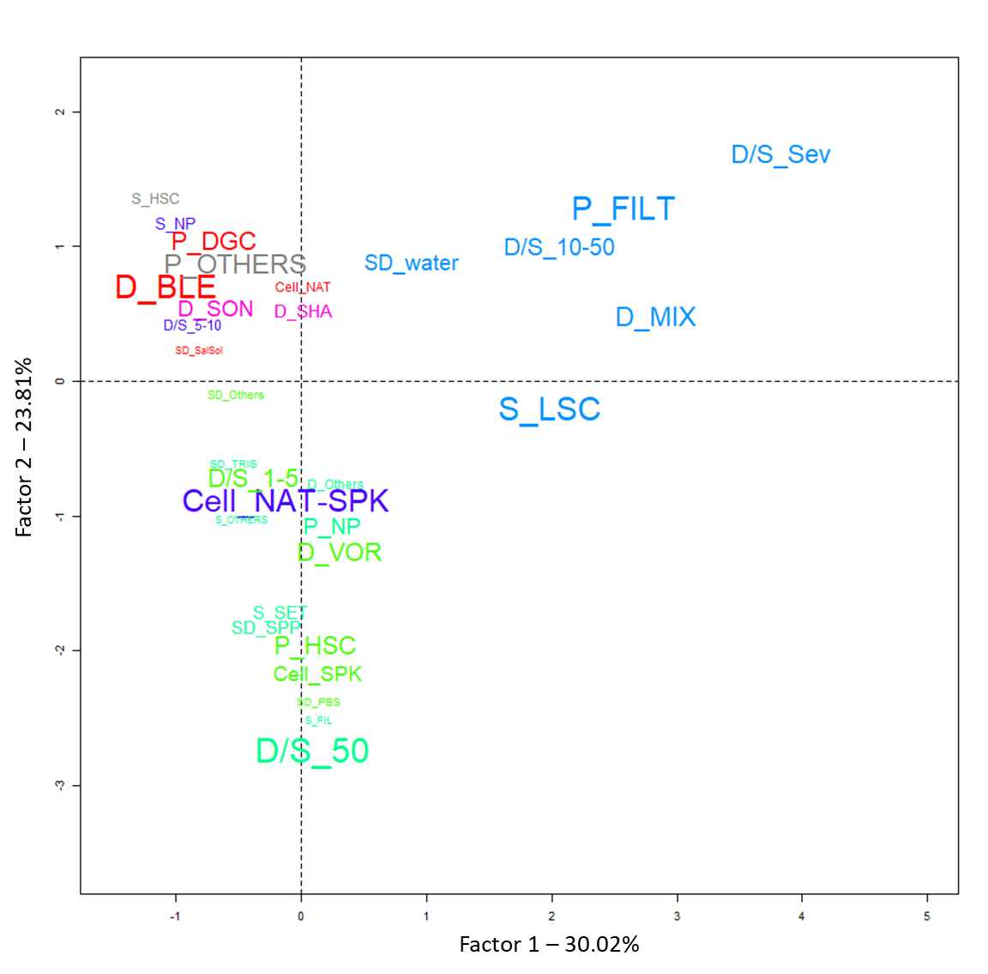
Figure S4. Post-hoc correspondence factor analysis performed after Reinert’s classification based on six categorical variables. Size of each modality is proportional to its Chi square value and indicates the association strength with the class. D: dispersion treatment (BLE: blending, MIX: mixing, SHA: shaking, SON: sonication, VOR: vortexing), S: separation treatment (DGC: density-gradient centrifugation, FIL: filtration, HSC: high-speed centrifugation LSC: low-speed centrifugation, SET: settling, NP: not performed), P: purification treatment (DGC: density-gradient centrifugation, FIL: filtration, HSC: high-speed centrifugation, NP: not performed). In all cases, OTHERS: combination of different method or less frequent methods used. Cell: cell type extracted (NAT: native, SPK: spiked). SD: soil diluent (water, SPP: sodium pyrophosphate, TRIS: Tris buffers, SalSol: saline solution, PBS: phosphate buffered saline, Others: diluent combinations or less frequent diluent used). D/S diluent/soil ratio (Sev: several ratios used).

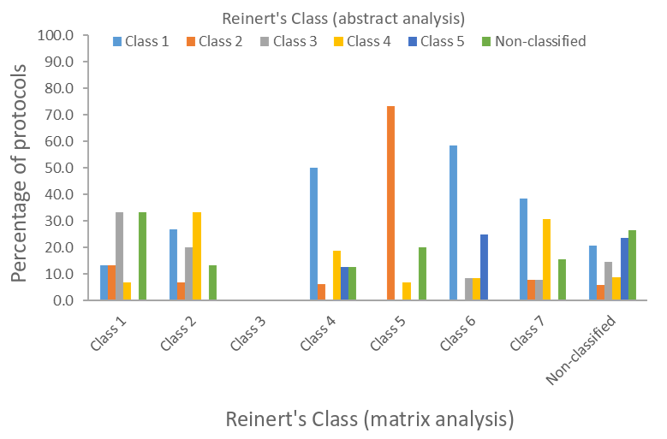
Figure S5. Percentage of protocols classified on Reinert’s classes (abstract analysis) among Reinert’s class (matrix analysis). Chi square test was significant (p< 0.001) but with theoretical values below 5.

